aim games  
Sprint 1 review

# Summons

|  |  |
| --- | --- |
| Name | Roll |
| De la Fuente Bonilla, Fco. Javier | **CEO, Project manager** |
| Molina Domínguez, Jorge Manuel | **CCO,CIO** |
| Bizcocho González, Mario | **CMO, Product Owner** |
| Arenas Arenas, Antonio  Monteseirín Puig, Alejandro  Pazo Jiménez, Pablo  Pérez Piñero, Iván  Santos Batista, Miguel | **Developers** |

# attendee

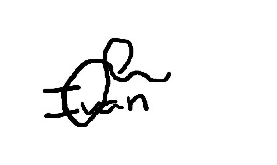**De la Fuente Bonilla, Fco. Javier Pérez Piñero, Iván**

**Arenas Arenas, Antonio Molina Domínguez, Jorge Manuel**

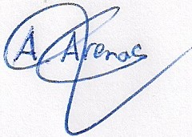

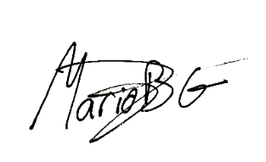**Monteseirín Puig, Alejandro Bizcocho González, Mario**

**Santos Batista, Miguel Pazo Jiménez, Pablo**

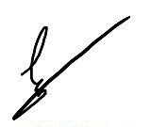

# Absent

No Proceed

# Date and place

Being on Friday March 22, 2019, and verified the attendance of all the summoned, began at 11:15 hrs. To the Sprint review meeting for the AIM GAMES project, which ended at 12:30 hrs.

# AGENDA

1º Review of things created to date and discuss problems that have showed up

# Development of the meeting and agreements

## Review of things created to date and discuss problems that have showed up

During the meeting there was a discussion about how the sprint was going and the biggest problems that were encountered in terms of organization and development.

The main problems were on the coordination when doing push to the repository, problem of the database when doing tests and with the payment of PayPal

To this end, measures have been taken with respect to each of them, follow the Gitflow methodology, create a script to popularize the database and final decision to use PayPal to pay when registering.

It has also been decided to delay in the sprint some tasks of Thread to give time to perform other core tasks.

# Signed in conformity

